Hands On Session
JWT Authentication Service

This is a Spring Boot application that provides JWT (JSON Web Token) authentication for RESTful web services.
## Project Structure
```
src/main/java/com/example/jwtauthservice/
├── JwtAuthServiceApplication.java # Main application class
├── config/
│ ├── SecurityConfig.java # Spring Security configuration
│ └── DataInitializer.java # Data initialization
├── controller/
│ ├── AuthController.java
│ └── AuthenticationController.java
├── entity/
│ └── User.java
├── filter/
│ └── JwtAuthenticationFilter.java
├── repository/
│ └── UserRepository.java
├── service/
│ └── CustomUserDetailsService.java
└── util/
└── JwtUtil.java
```

## Features
- JWT token generation and validation
- HTTP Basic Authentication for login
- H2 in-memory database integration (default)
- Spring Security configuration
- Stateless authentication

## Prerequisites
- Java 11 or higher
- Maven 3.6 or higher

## Database Setup
By default, the application uses an H2 in-memory database.
No setup is required.
If you want to use MySQL, update the `src/main/resources/application.properties` file accordingly.

## Running the Application
1. Build the project:
```bash
mvn clean package
```

2. Run the application:
```bash
mvn spring-boot:run
```

The application will start on port 8090.

## API Endpoints
### Authentication
**POST** `/authenticate`
Authenticate a user and receive a JWT token.
**Request (x-www-form-urlencoded):**
- `username`: user
- `password`: pwd
**Example using curl:**
```bash
curl -X POST http://localhost:8090/authenticate -d "username=user&password=pwd"
```
**Response:**
```json
{
"token": "eyJhbGciOiJIUzI1NiJ9..."
}
```
### Protected Endpoint

**GET** `/hello`
Access a protected endpoint using the JWT token.

**Example using curl:**
```bash
curl -H "Authorization: Bearer YOUR_JWT_TOKEN" http://localhost:8090/hello
```

## Testing with Postman

1. **Authenticate:**
- Method: POST
- URL: `http://localhost:8090/authenticate`
- Body: `x-www-form-urlencoded`
- `username`: `user`
- `password`: `pwd`
- Click **Send** and copy the `token` from the response.
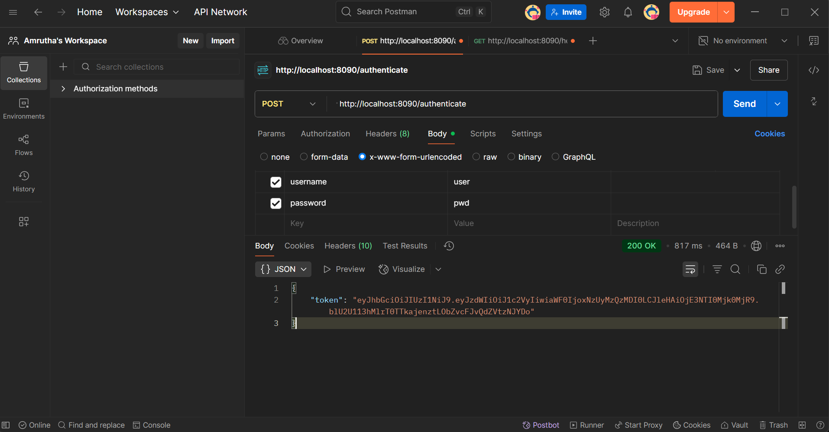

2. **Access Protected Endpoint:**
- Method: GET
- URL: `http://localhost:8090/hello`
- Authorization: Bearer Token (paste the token from step 1)
- Click **Send** to see the protected message.
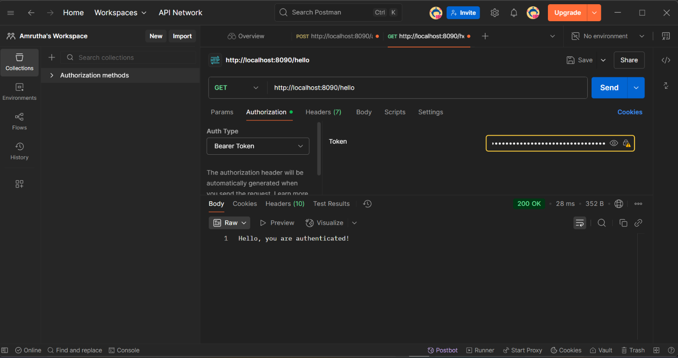

## Default Test User
The application creates a test user automatically:
- Username: `user`
- Password: `pwd`

## JWT Configuration
JWT settings can be configured in `application.properties`:
```properties
jwt.secret=mySecretKey123456789012345678901234567890123456789012345678901234567890
jwt.expiration=86400000
jwt.header=Authorization
jwt.prefix=Bearer
## Security Features
- HTTP Basic Authentication for initial login
- JWT token generation with expiration
- Stateless session management
- Password encryption using BCrypt
- Role-based access control

## H2 Console
You can access the H2 database console at:
[http://localhost:8090/h2-console](http://localhost:8090/h2-console)
JDBC URL: `jdbc:h2:mem:testdb`
Username: `sa`
Password: `password`

## Testing
You can test the application using the provided curl commands or any REST client like Postman.

